Elijah McLaughlin

November 13, 2023

STA 3064

Assignment 3

1. m
   1. A graph of a person

      Description automatically generated  
      The curves are similar, however, with the new values the curve was shortened.
   2. A graph of a person

      Description automatically generated  
      The curves are identical, and shifted right with the new value.
   3. A graph of a number of lines

      Description automatically generated with medium confidence  
      The curves are similar. With the new value, the curve widened.
   4. A graph of a person

      Description automatically generated  
      The curves are identical. With the new values, the curve shifted to the left.
   5. A diagram of a graph

      Description automatically generated  
      The curves are identical, the new values created an inverse.
2. (-1, -1) goes with plot 2, (-1, 0) goes with plot 6, (-1, 1) goes with plot 4, (0, -1) goes with plot 9, (0, 0) goes with plot 1, (0, 1) goes with plot 5, (1, -1) goes with plot 7, (1, 0) goes with plot 8, and (1, 1) goes with plot 3.
   1. A graph of a function

      Description automatically generated  
      It’s shape shows that this player has the highest chance of making a shot is between 10 and 15 feet.
   2. 1.1052
   3. 0.5259
   4. New odds = 0.9048. Change = 0.8189
   5. New odds = 0.5250. Change = 0.05
   6. Distance = 10.4727 ft, or about 10 and a half feet.
   7. A graph with a line

      Description automatically generated  
      There is a positive relationship between REMISS and LI.
   8. A screenshot of a test results

      Description automatically generated  
      Since Pr > ChiSq is less than 0.05, it is statistically significant.
   9. The relationship is positive, and it is logical. If LI is higher, it follows that remission has a higher likely.
   10. 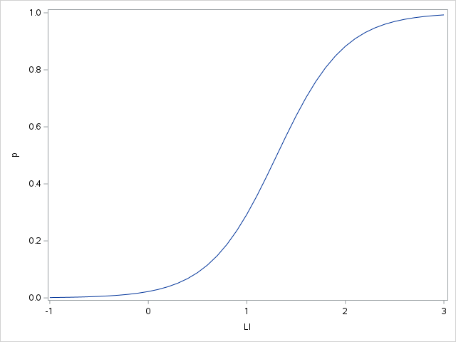  
       About 30%.